PSG COLLEGE OF TECHNOLOGY, COIMBATORE – 641 004
Department of Applied Mathematics and Computational Sciences
M Sc SOFTWARE SYSTEMS – Semester IV
20XW48 – Web Designing Lab
PROBLEM SHEET 1 – HTML Basic Tags

Start Date: 23.12.2021 Complete Date: 30.12.2021

- Write HTML code to develop a web page having the background in red and title as “My First Page”.

<!doctype html>
<html>

<head>
<title>My first webpage</title>
</head>

<body style="background-color:red">

</body>
</html>

- Print the numbers 1 - 10, each number being a different color.
<!doctype html>
<html>

<head>
<title>My first webpage</title>
</head>

<body style="background-color:red">
<h1>heki</h1>
<font color="blue">
1<br>
</font>

<font color="white">
2<br>
</font>

<font color="cyan">
3<br>
</font>

<font color="green">
4<br>
</font>

<font color="yellow">
5<br>
</font>

<font color="blue">
6<br>
</font>

<font color="brown">
7<br>
</font>

<font color="yellow">
8<br>
</font>

<font color="blue">
9<br>
</font>

<font color="white">
10<br>
</font>

</body>

</html>

- Create a HTML document giving details of your name, age, mobile no, address & enrollment no. aligned in proper order
<!doctype html>
<html>

<head>
<title>My first webpage</title>
</head>

<body>
<h1> <center> Name : Kart </center> </h1>

<p> <center> <h6> Address: dubai kuruku sandhu , cbe-43 </h6> </center> </p>

<p align="right"> hello warudo </p>

</body>

</html>
- Write a HTML code to print your name with different heading style.
<!doctype html>
<html>

<head>
<title>My first webpage</title>
</head>

<body>
<h1> Karthik manian S </h1>
<h2> Karthik Manian S </h2>
<h3> Karthik Manian S </h3>
<h4> Karthik manian s </h4>
<h5> Karthik Manian S </h5>
<h6> Karthik manian s</h6>
</body>
</html>

- Print a paragraph that is a description of a book, include the title of the book as well as its author. Names and titles should be underlined, adjectives should be italicized and bolded.
<!doctype html>
<html>

<head>
<title>My first webpage</title>
</head>

<body>
<h1> <center> ONE PIECE </center> </h1>
<h2> <center>Author: <em> Eiichiro Oda </em> </center>
<br>
<p> The series focuses on Monkey D. Luffy, a rubberized young man who, inspired by his childhood idol, the powerful pirate "Red Haired" Shanks, sets off on a journey from the East Blue Sea to find the mythical One Piece and proclaim himself the King of the Pirates. In an effort to organize his own crew, the Straw Hat Pirates,[Jp 1] Luffy rescues and befriends a pirate hunter and swordsman named Roronoa Zoro, and they head off in search of the titular treasure. They are joined in their journey by Nami, a money-obsessed thief and navigator; Usopp, a sniper and compulsive liar; and Vinsmoke Sanji, a perverted but chivalrous chef. They acquire a ship, the Going Merry[Jp 2], and engage in confrontations with notorious pirates of the East Blue. As Luffy and his crew set out on their adventures, others join the crew later in the series, including Tony Tony Chopper, an anthropomorphized reindeer doctor; Nico Robin, an archaeologist and former Baroque Works assassin; Franky, a cyborg shipwright; Brook, a skeleton musician and swordsman; and Jimbei, a fish-man helmsman and former member of the Seven Warlords of the Sea. Once the Going Merry becomes damaged beyond repair, the Straw Hat Pirates acquire a new ship, the Thousand Sunny,[Jp 3] built by Franky. Together, they encounter other pirates, bounty hunters, criminal organizations, revolutionaries, secret agents, and soldiers of the corrupt World Government, and various other friends and foes, as they sail the seas in pursuit of their dreams. </p>

</body>
</html>

- Print a paragraph with 4 - 5 sentences. Each sentence should be in a different font.
- Design a page having background color, given text color red and use all the attributes of font tag.
- Print the squares of the numbers 1 - 20. Each number should be on a separate line, next to it the number 2 superscripted, an equal sign and the result. (Example: 10² = 100)
- Prints 10 names with a line break between each name. The list should be alphabetized, and to do this place a subscripted number next to each name based on where it will go in the alphabetized list. (Example: Alan₁). Print first, the unalphabetized list with a subscript number next to each name, then the alphabetized list. Both lists should have an <h1> level heading.
- Print two paragraphs that are both indented using the &nbsp; command.
- Print two lists with any information you want. One list should be an ordered list, the other list should be an unordered list.
- Create a HTML document containing three ordered lists: ice cream, soft serve and frozen yogurt. Each ordered list should contain a nested, unordered list of your favorite flavors. Provide a minimum of three flavors in each unordered list.
- Prints an h1 level heading followed by a horizontal line whose width is 100%. Below the horizontal line print a paragraph relating to the text in the heading.
- Print some preformatted text of your choosing. (hint: use the <pre> tag)
- Print a long quote and a short quote. Cite the author of each quote.
- Print some deleted and inserted text of your choosing.
- Print a definition list with 5 items.
- Print two addresses in the same format used on the front of envelopes (senders address in top left corner, receivers address in the center).
- Print ten acronyms and abbreviations of your choosing, each separated by two lines. Specify the data that the abbreviations and acronyms represent.
- Write a HTML code to create a web page of blue color and display links in red color.
- Create some links to various search engines (google, yahoo, altavista, lycos, etc).
- Create links to five different pages on five different websites that should all open in a new window.
- Create a page with a link at the top of it that when clicked will jump all the way to the bottom of the page. At the bottom of the page there should be a link to jump back to the top of the page.
- Design a web page to display five different images. Skip two lines between each image. Each image should have a title. Also, display each image that has a border of size 2, a width of 200, and a height of 200.
- Design a web page with two images, when the first image clicked will link to a search engine of your choice (should be opened in a new window) and when the second image clicked will link to itself and will display the image in the browser by itself.
- Design a web page as shown below using text formatting elements and lists:
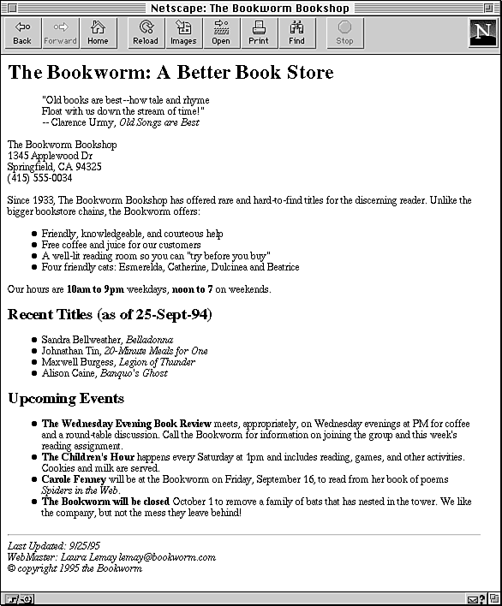
- Design a web page as shown below using text formatting elements:
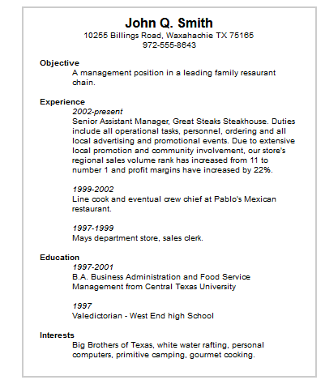
- Design the below table using HTML with background image and also with real time data (atleast five records).
Train No. | Name of the Train | Place | Destination | Time |  | Fare
 |  |  |  | Arrival | Departure | Fare
….
….

- Write a HTML code to design a table filled with images in each cell.
1 | 2 | 3 | 4
5 | Image |  | 6
7 |  |  | 8
9 | 10 | 11 | 12

- Design the below table shows the seminar schedule
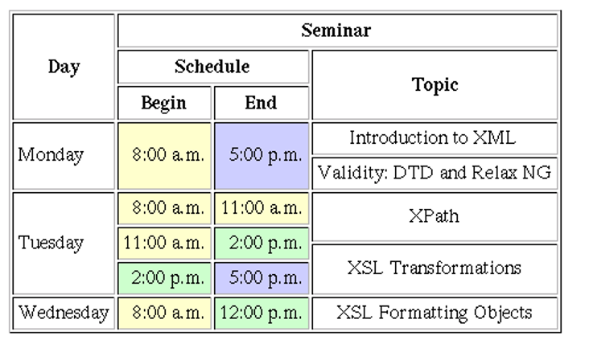
- Design a home with the contents shown below using Nested tables
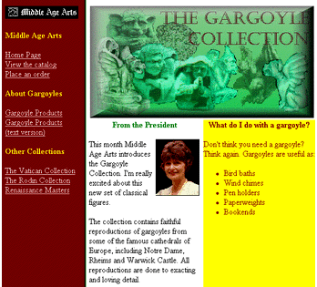

Web Resources:
- https://www.quackit.com/html/tutorial/introduction.cfm
- https://www.w3schools.com/html/
- https://www.tutorialspoint.com/html/
- http://htmldog.com/guides/html/

